M 054 Defending Turning in attack, 2 v 2 attacking and defending.

Requirements: Half a pitch, a goal with net and keeper two markers, all players.

General Scenario: A large mini goal about three metres outside of the penalty area, is set up. Teams split into two teams, one team in pairs start as attackers shown in (A Team Blue) and form up near the centre spot on the half way line. The defenders (B Team Red) line up at the goal line (either side of goal).  Two defenders sprint forward, one (B1) taking up position in the mini goal and one (B2) deeper in the penalty area. One of the attackers (A1) (Blue), sprints forward and turns in the mini goal to face the half way line. | 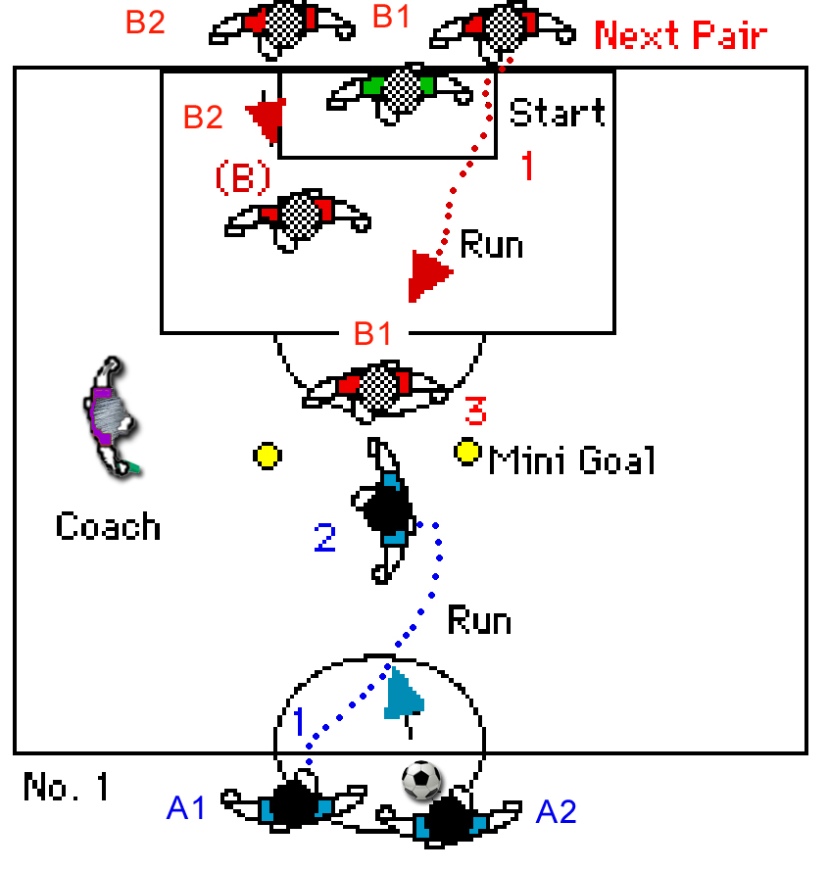

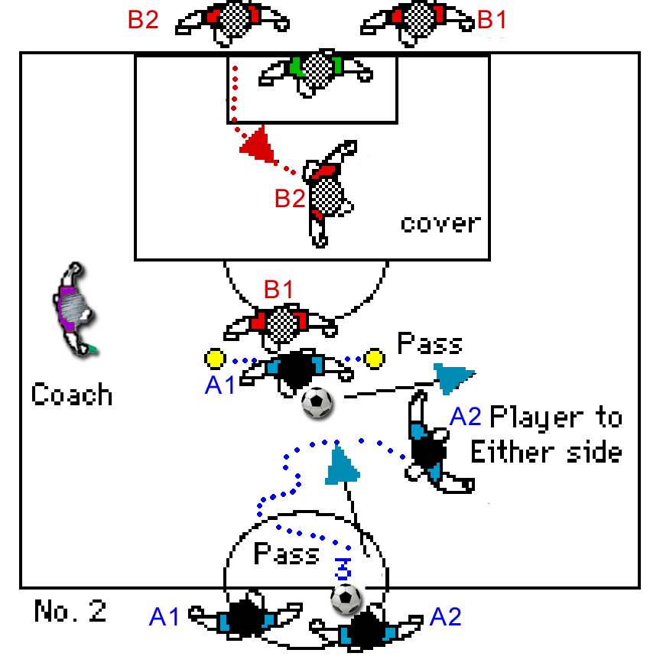 | The second attacker (A2), (with the ball)  then passes to attacker (A1) and then sprints forward going either side of the mini goal. The first attacker (A1), must hold up the ball (must shield the ball) and move sideways along the mini goal, and then feed the oncoming player (A2) with a good pass on either side.  They both then attack the goal, with the attacker (A1) breaking opposite to the other attacker.  The second defender must move to take on the second attacker.

The defenders must be passive near the mini goal – they cannot move in front of the mini goal markers.

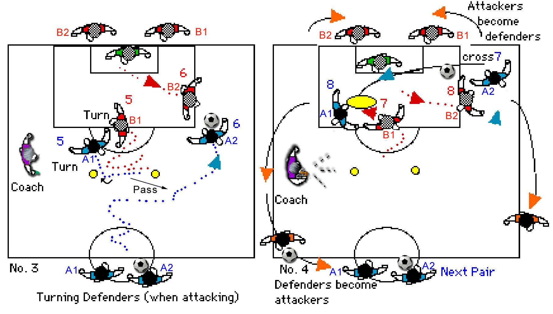
The mini goal defender (B1) goes with the first attacker (A1) and tries to defend on this player. The second defender (B2) moves to challenge the player with the ball. Attackers MUST make at least one more pass or cross, before shooting for goal. | Attackers swap with defenders, the defending team collect the ball and move to the halfway line, the attackers move behind the goals and they then take up opposite roles. Players (A1) should also swap roles with Players (A2), so that each try different roles.

Note: It is important to wait until each attack is concluded before allowing the next group into the grid. Do not allow players to move into the grid without your signal.

Play commences: When the coach signals the next group in. Then when the first defending player (B1) sprints to the mini goal. Note: If tackled or unable to turn move ends.

Roles: Defenders To defend the turning attacking player and to break up any attack. Encourage and re-enforce good shots or defending.

Attacking players To break early and go together as a unit. To turn the defender and move on goal to get a shot on goal.

Targets: Defenders To move quickly to run down the attacker, to act as an obstacle for the attacking player.

Attacking players To turn the defender and to link with the other attacker to get a clean shot on goal. Players change places after each set. Attackers become defenders etc.

Coaching Points -Turning skills, with pressure on getting into position early and moving at pace which means speed and good movement on and off the ball under pressure. Players normally change roles after each set however, if you want to exercise your defenders v attackers, let them remain in their repective roles (not changing after each attack), but defending/attacking in pairs of attackers or defenders, however make players swap (A) for (B) roles as defenders or attackers after each run.

Developments

i. Increase the distance of the mini goal from the goal to improve attacking skills, decrease to improve defending skills.

ii. Add an extra attacker or defender or both to the grid (these players remain for each group). But must touch the posts after each attack.

Move the permanent attackers / defenders to be far side, central or near side (I found the central position works best then they have to make a decision on which side to cover.

Seen here permanent attacker/defenders are moving back into play



